
Lesson 7: On the Move
GDevelop
VIDEO GAME CREATION
This week: enemies stop standing still. Your job is to make every enemy advance slowly toward the player, and clean up any that reach the bottom of the screen without being shot.
Open your own [YourName]Game project from Lesson 6 - don't start a new one.
Tip: no new assets this week - this is a logic-only lesson.

Setup
- Open your [YourName]Game project from Lesson 6.

Level 1 - Minimal (MVP)
Every enemy moves slowly downward, toward the player, instead of sitting still. An enemy that reaches the bottom of the screen unshot is removed - and does NOT count toward your win condition, since it escaped rather than being defeated.
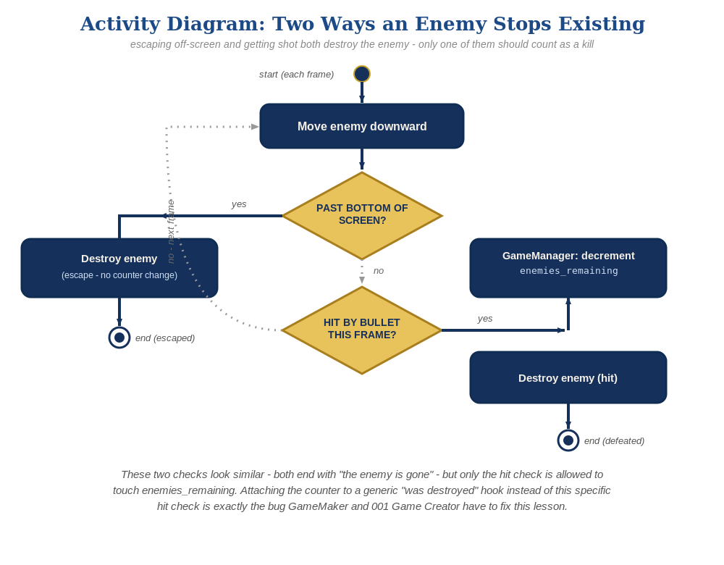
The general escape-vs-hit distinction behind this week's exercise - the same shape in every engine, whatever the exact code or blocks look like.
- Add a new "always" event (no condition): Action "Enemy.Y = Enemy.Y() + 30 * TimeDelta()" - this moves every Enemy instance downward, every frame.
- Add a second new event: Condition "Enemy.Y() > 750" -> Action "Delete Enemy" - this is a plain deletion, with no effect on EnemiesRemaining.
- Click the green Preview button and let the enemies drift downward - shooting one should still work exactly as before, and letting one reach the bottom unshot should just delete it, with no "You Win!" message.
(always, no condition)
Action: Enemy.Y = Enemy.Y() + 30 * TimeDelta()
Condition: Enemy.Y() > 750
Action: Delete Enemy

Level 2 - Complete (Alpha/Beta)
A moving enemy can still be shot and destroyed correctly, and an enemy that escapes off the bottom never triggers "You Win!" by accident.
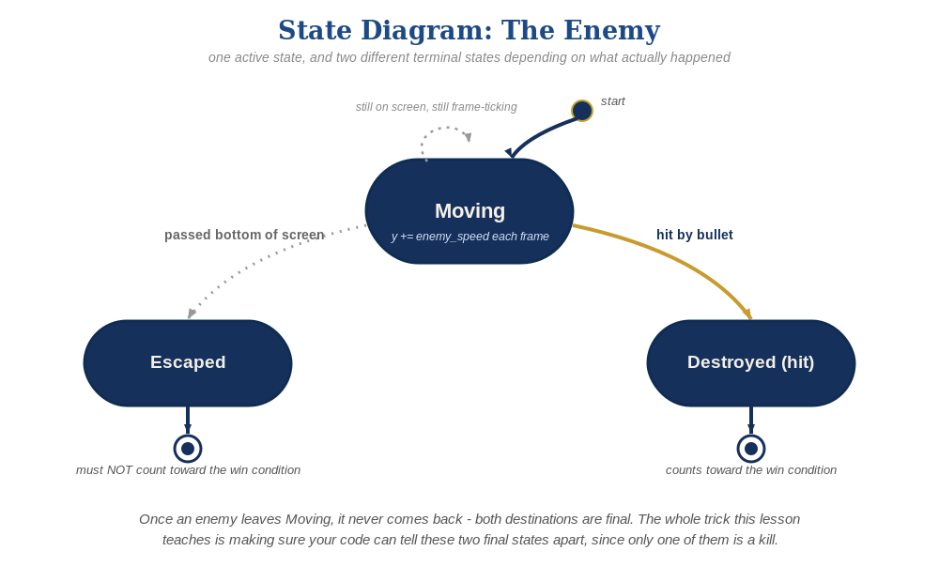
The enemy's two possible endings this week - only one of them should count as a kill.
- Shoot a moving enemy to confirm the Combat event group's collision condition still fires correctly while it's in motion.
- Let at least one enemy escape off the bottom unshot, and confirm "You Win!" does NOT appear - only the Combat group's collision event ever changes EnemiesRemaining, and the new escape-cleanup event never touches it.

Level 3 - Refined (Ready to Publish) - pick any that interest you
- Visual: use a random per-instance speed instead of a fixed 30 - GDevelop's "Enemy.Y = Enemy.Y() + (30 + Random(20)) * TimeDelta()" gives each instance a slightly different feel without extra events.
- Structure: group the movement and escape-cleanup events into their own labeled group (e.g. "Enemy Movement"), separate from "Combat" and "Spawn Enemies" - three clearly separate concerns as the event sheet grows.

If Something's Wrong
- "You Win!" appears even when enemies escaped unshot: confirm the escape-cleanup event only has a "Delete Enemy" action, with no EnemiesRemaining action anywhere near it.
- Enemies don't move: confirm the movement event truly has no condition attached (an empty condition list, not a false one) so it runs every single frame.
- Enemies move but never disappear at the bottom: confirm the Enemy.Y() > 750 threshold actually matches your project's scene height.

Want More?
Student Resource List > GDevelop section, or gdevelop.io/tutorials

